1. For the given JSON iterate over all for loops(for, for in, for of, for Each)

**Sample JSON Response:**

Let data=[{

"id": 1,

"first_name": "John",

"last_name": "Smith",

"email": "JohnSmith23@gmail.com"

},

{

"id": 2,

"first_name": "Mike",

"last_name": "Dean",

"email": "MikeDean56@gmail.com"

}

}];

**For…Each loop:**

function fetchData() {

data.forEach(obj => {

Object.entries(obj).forEach(([key, value]) => {

console.log(`${key} ${value}`);

});

console.log('-------------------');

});

}

**Result:**

**id 1**

**first_name John**

**last_name Smith**

**email JohnSmith23@gmail.com**

**-------------------**

**id 2**

**first_name Mike**

**last_name Dean**

**email** [**MikeDean56@gmail.com**](mailto:MikeDean56@gmail.com)

**for…in loop:**

var iterateData = function(data){

for (var key in data) {

if (data.hasOwnProperty(key)) {

console.log(“Id: “+data[key].id);

console.log(“First Name: “+data[key].first_name);

console.log(“Last Name: “+data[key].last_name);

console.log(“Email: “+data[key].email);

console.log(“**-------------------“);**

}

}};

**Result:**

**Id: 1**

**First_Name: John**

**Last_Name: Smith**

**Email: JohnSmith23@gmail.com**

**-------------------**

**Id: 2**

**First_Name: Mike**

**Last_Name: Dean**

**Email:** [**MikeDean56@gmail.com**](mailto:MikeDean56@gmail.com)

**For loop:**

for(let i = 0; i < data.length; i++) {

let obj = data[i];

console.log(“Id: “+obj.id);

console.log(“First_Name: “+obj.First_Name);

console.log(“Last_Name: “+obj.Last_name);

console.log(“Email: “+obj.Email);

}

**Result:**

**Id: 1**

**First_Name: John**

**Last_Name: Smith**

**Email: JohnSmith23@gmail.com**

**-------------------**

**Id: 2**

**First_Name: Mike**

**Last_Name: Dean**

**Email:** [**MikeDean56@gmail.com**](mailto:MikeDean56@gmail.com)

1. Create your own resume data in JSON format

**Index.html**

<!DOCTYPE html>

<html lang="en">

<head>

    <meta charset="UTF-8">

    <meta http-equiv="X-UA-Compatible" content="IE=edge">

    <meta name="viewport" content="width=device-width, initial-scale=1.0">

    <title>Document</title>

</head>

<body>

    <h1>Resume generated in JSON format

    </h1>

    <script src="script.js"></script>

</body>

</html>

**Script.js**

let myResume={

    "basics": {

      "name": "Mohan Kumar",

      "email": "mohank6@gamil.com",

      "phone": 8925687495,

      "degree": "B.E",

    },

    "Work Experience": [

      {

        "company": "TCS",

        "position": "Associate Consultant",

        "Years of Experience": "3",

      },

    ],

    "education": [

      {

        "institution": "Anna University",

        "department": "ECE",

        "Batch": "2015-2019" ,

        "gpa": 7.8,

      }

    ],

    "skills": [

      {

        "name": "python,javascript,sql,java",

      }

    ],

    "languages": [

      {

        "language": "Tamil,Enlish",

      }

    ],

  }

  console.log(myResume);

**Result:**

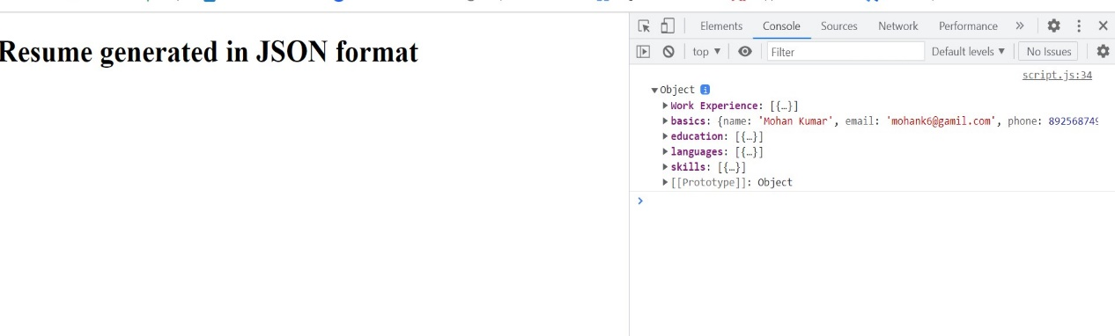

1. Difference between window, screen and document in javascript

|  |  |  |
| --- | --- | --- |
| **Document** | **Window** | Screen |
| It represents any HTML document or web page that is loaded in the browser. | It represents a browser window or frame that displays the contents of the webpage. | The Screen is the screen, it contains properties about the user display on which current window is rendered. |
| It is loaded inside the window. | It is the very first object that is loaded in the browser. | Refers screen object associated with window. |
| Object of window property. | Object of the browser. | Object of the browser |
| All the tags, elements with attributes in HTML are part of the document. | Global objects, functions, and variables of JavaScript are members of the window object. | Display screen width, height, colour etc. |
| We can access the document from a window using the **window. document** | We can access the window from the window only. i.e. **window.window** | We can access the screen from window. i.e: **window.screen** |
| Document is part of BOM (browser object model) and dom (Document object model) | Window is part of BOM, not DOM. | Screen is part of BOM, not DOM. |
| Properties of document objects such as title, body, cookies etc can also be accessed by a window like this window. document.title | Properties of window object cannot be accessed by the document object. | Properties of screen object can be accessed by Screen object |
| **syntax:** document.propertyname; | **syntax:** window.propertyname; | **Syntax**: screen.propertyname; |